**SUBJECT**: DESIGN AND ANALYSIS OF ALGORITHMS

**CODE**: 503040

Duration: 135 minutes

Allowed to use materials.

**LAB 04: Divide-and-Conquer**

# Idea

1. Divide the problem into parts.
2. Solve each part recursively.
3. Combine the Solutions.
4. Complexity is usually of form $T (n) = aT (\frac{n}{b}) + f(n)$
5. Recurrence relation can be solved with Master Theorem.

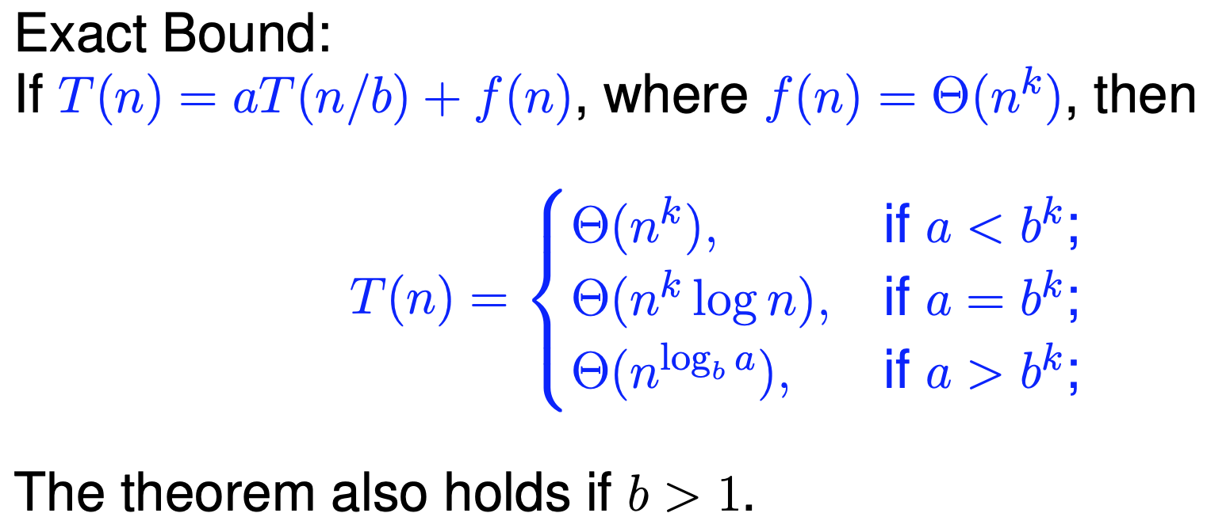

## An example of a divide-and-conquer algorithm

Pseudocode of MergeSort algorithm is given as follows:

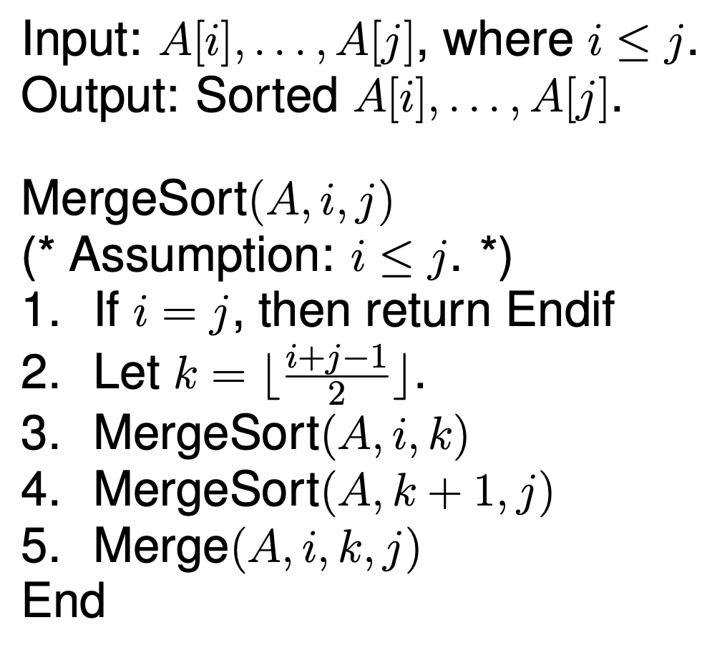

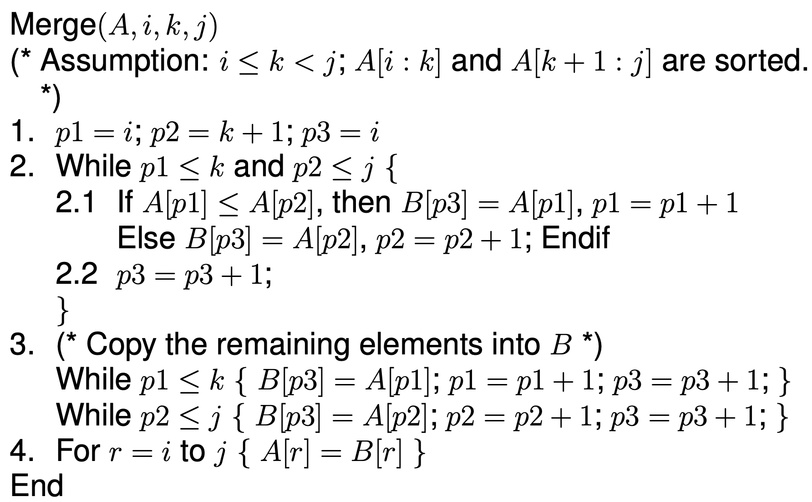

The MergeSort algorithm analysis

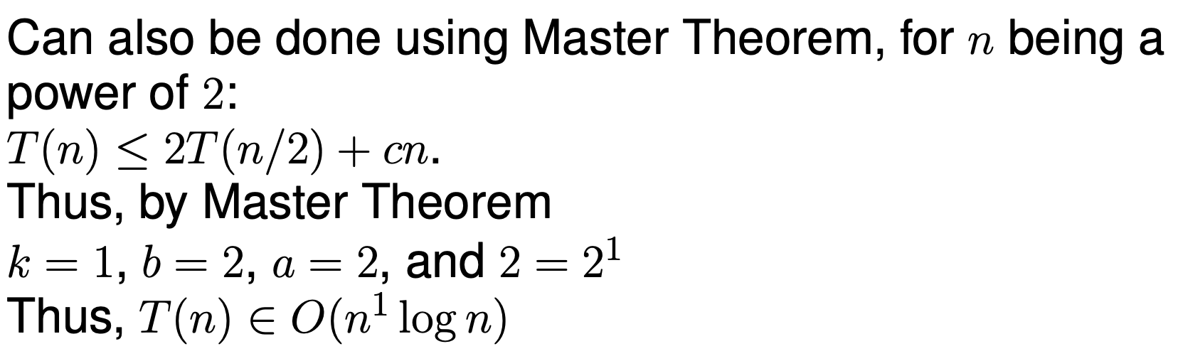

Implementation of MergeSort in Python is presented as follows

import timeit

from random import shuffle

def mergesort(A, i, j):

if i == j: return None

k = (i + j)//2

mergesort(A,i,k)

mergesort(A,k+1,j)

merge(A, i, k, j)

def merge(A,i,k,j):

B = [0 for _ in range(len(A))]

p1, p2, p3 = i, k+1, i

while p1 <= k and p2 <= j:

if A[p1] < A[p2]:

B[p3] = A[p1]

p1 += 1

else:

B[p3] = A[p2]

p2 += 1

p3 += 1

while p1 <= k:

B[p3] = A[p1]

p3 += 1

p1 += 1

while p2 <= j:

B[p3] = A[p2]

p3 += 1

p2 += 1

for r in range(i, j+1):

A[r] = B[r]

x = list(range(400))

shuffle(x)

print(x)

start = timeit.default_timer()

mergesort(x,0, len(x) - 1)

stop = timeit.default_timer()

print(x)

print('Time: ', stop - start)

# Exercises

For each of the problems in this section, implement (in Python) and analyze a divide-and-conquer algorithm to solve the problem.

**Warm-up exercise**

1. Find an element in an ascending sorted array.

**Intermediate** **exercises**

1. Sort an array with Quicksort

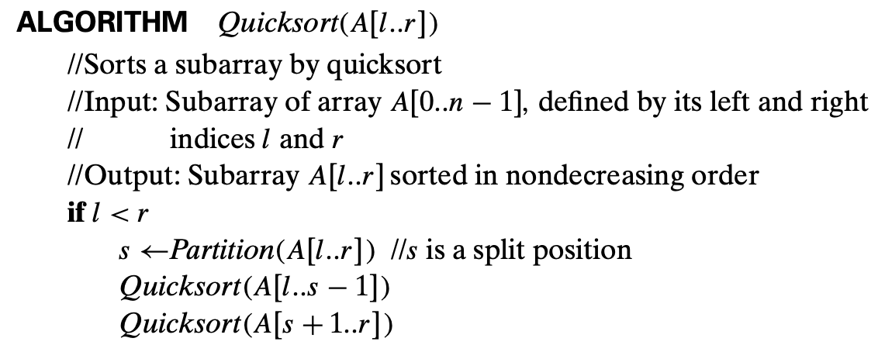

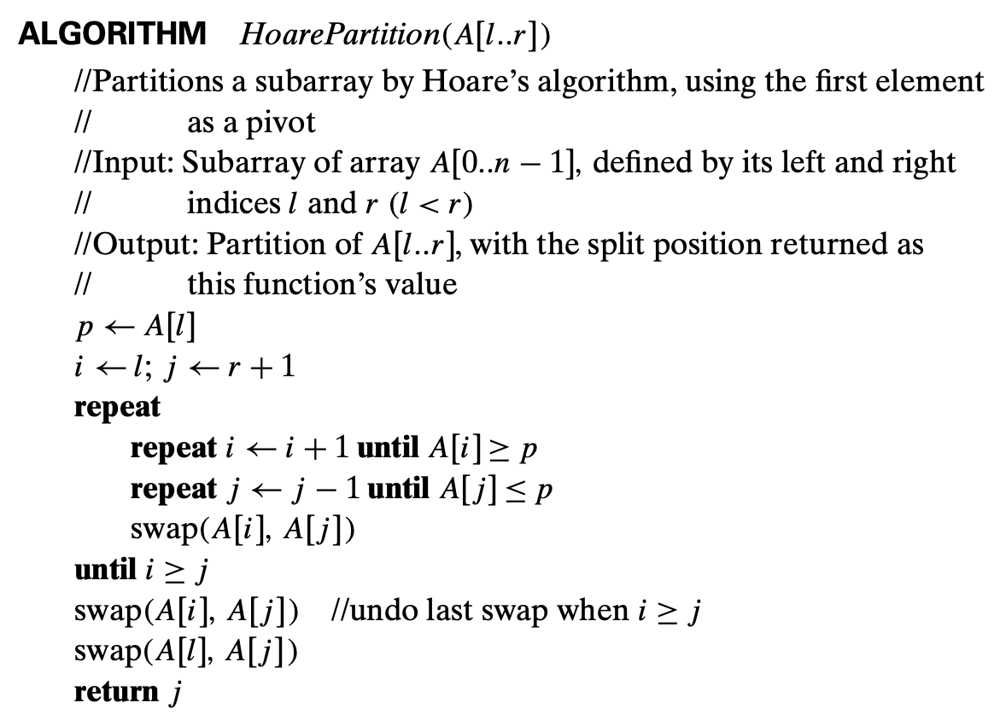

1. Identify the height of a binary tree. Suppose that the height of a tree containing a single node is 0.
2. Traverse a binary tree in Pre-order, Post-order, In-order.

Node = (value, Left, Right)

Node = (1, None, None)

Node0 = (1, Node, None)